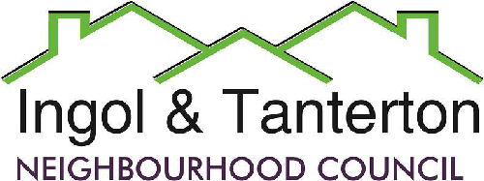

**Agenda**

**A meeting of the Ingol and Tanterton Neighbourhood Council Finance & Asset Committee will be held on Thursday 26th June 2025 at 6pm at Tanterton Village Centre.**

1.To receive apologies.

2.To receive declarations of interest and dispensations.

3.Public participation.

4.To approve the minutes of the January Finance Committee Meeting.

5.To review the Ingol Dip project total spend, received grants and VAT return.

6.To complete a mini audit and bank reconciliation.

7.To approve the performance against budget report and the CIL report.

8.To approve the financial risk assessment and financial risk summary.

Press and public are welcome to attend.